
AAAS
Health Data Science
Volume 2021, Article ID 8786793, 14 pages https://doi.org/10.34133/2021/8786793

Review Article

Advances in Deep Learning-Based Medical Image Analysis

Xiaoqing Liu,¹ Kunlun Gao,¹ Bo Liu ,¹ Chengwei Pan ,¹ Kongming Liang,¹ Lifeng Yan ,¹ Jiechao Ma,¹ Fujin He,¹ Shu Zhang,¹ Siyuan Pan ,² and Yizhou Yu^{1,3}
¹DeepWise AI Lab, Beijing, China
²Shanghai Jiaotong University, Shanghai, China
³The University of Hong Kong, Hong Kong
Correspondence should be addressed to Yizhou Yu; yizhouy@acm.org
Received 18 November 2020; Accepted 4 March 2021; Published 16 June 2021
Copyright © 2021 Xiaoqing Liu et al. Exclusive Licensee Peking University Health Science Center. Distributed under a Creative Commons Attribution License (CC BY 4.0).
Importance. With the booming growth of artificial intelligence (AI), especially the recent advancements of deep learning, utilizing advanced deep learning-based methods for medical image analysis has become an active research area both in medical industry and academia. This paper reviewed the recent progress of deep learning research in medical image analysis and clinical applications. It also discussed the existing problems in the field and provided possible solutions and future directions. Highlights. This paper reviewed the advancement of convolutional neural network-based techniques in clinical applications. More specifically, state-of- the-art clinical applications include four major human body systems: the nervous system, the cardiovascular system, the digestive system, and the skeletal system. Overall, according to the best available evidence, deep learning models performed well in medical image analysis, but what cannot be ignored are the algorithms derived from small-scale medical datasets impeding the clinical applicability. Future direction could include federated learning, benchmark dataset collection, and utilizing domain subject knowledge as priors. Conclusion. Recent advanced deep learning technologies have achieved great success in medical image analysis with high accuracy, efficiency, stability, and scalability. Technological advancements that can alleviate the high demands on high-quality large-scale datasets could be one of the future developments in this area.

Introduction
Downloaded from https://spj.science.org on November 05, 2025
With rapid developments of artificial intelligence (AI) tech- nology, the use of AI technology to mine clinical data has become a major trend in medical industry [1]. Utilizing advanced AI algorithms for medical image analysis, one of the critical parts of clinical diagnosis and decision-making, has become an active research area both in industry and aca- demia [2, 3]. Recent applications of deep leaning in medical image analysis involve various computer vision-related tasks such as classification, detection, segmentation, and registra- tion. Among them, classification, detection, and segmenta- tion are fundamental and most widely used tasks.
Although there exist a number of reviews on deep learn- ing methods on medical image analysis [4–13], most of them emphasize either on general deep learning techniques or on specific clinical applications. The most comprehensive review paper is the work of Litjens et al. published in 2017 [12]. Deep learning is such a quickly evolving research field; numerous state-of-the-art works have been proposed since
then. In this paper, we review the latest developments in the field of medical image analysis with comprehensive and representative clinical applications.
We briefly review the common medical imaging modalities as well as technologies for various specific tasks in medical image analysis including classification, detection, segmentation, and registration. We also give more detailed clinical applications with respect to diﬀerent types of diseases and discuss the existing problems in the field and provide possible solutions and future research directions.

AI Technologies in Medical Image Analysis
Diﬀerent medical imaging modalities have their unique char- acteristics and diﬀerent responses to human body structure and organ tissue and can be used in diﬀerent clinical pur- poses. The commonly used image modalities for diagnostic analysis in clinic include projection imaging (such as X-ray imaging), computed tomography (CT), ultrasound imaging, and magnetic resonance imaging (MRI). MRI sequences

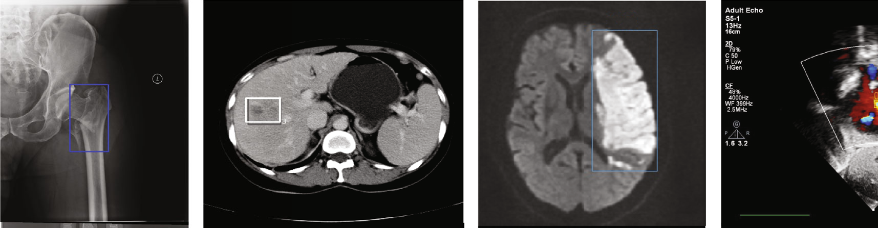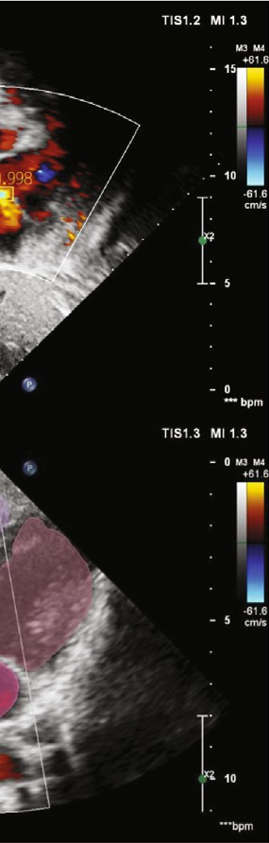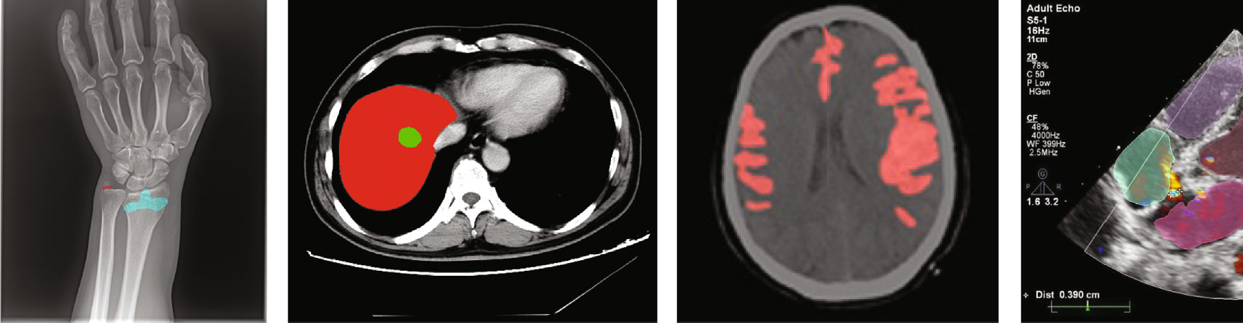
0.99
0.994
0.68
L
Bone X-ray Liver CT Brain MRI Cardiac ultrasound
Figure 1: Examples of medical image modalities and their corresponding applications (original copy).

include T1, T1-w, T2, T2-w, diﬀusion-weighted imaging (DWI), apparent diﬀusion coefficient (ADC), and fluid atten- uation inversion recovery (FLAIR). Figure 1 demonstrates a few examples of medical image modalities and their corre- sponding clinical applications.
  - Image Classification for Medical Image Analysis. As a fundamental task in computer vision, image classification plays an essential role in computer-aided diagnosis. A straightforward use of image classification for medical image analysis is to classify an input image or a series of images as either containing one (or a few) of predefined diseases or free of diseases (i.e., healthy case) [14, 15]. Typical clinical appli- cations of image classification tasks include skin disease iden- tification in dermatology [16, 17], eye disease recognition in ophthalmology (such as diabetic retinopathy [18, 19], glau- coma [20], and corneal diseases [21]). Classification of path- ological images for various cancers such as breast cancer [22] and brain cancer [23] also belongs to this area.
Convolutional neural network (CNN) is the dominant classification framework for image analysis [24]. With the development of deep learning, the framework of CNN has continuously improved. AlexNet [25] was a pioneer convolutional neural network, which was composed of repeated convolutions, each followed by ReLU and max pooling operation with stride for downsampling. The pro- posed VGGNet [26] used 3×3 convolution kernels and 2×2 maximum pooling to simplify the structure of Alex-
Net and showed improved performance by simply increas- ing the number and depth of the network. Via combining
pay more attention to the most informative channel features. The family of EfficientNet [33] applied AUTOML and a com- pound scaling method to uniformly scale the width, depth, and resolution of the network in a principled way, resulting in improved accuracy and efficiency. Figure 2 demonstrates some of the commonly used CNN-based classification net- work architectures.
Besides the direct use for image classification, CNN- based networks can also be applied as the backbone models for other computer vision tasks, such as detection and segmentation.
To evaluate the algorithms of image classification, researchers use diﬀerent evaluation metrics. Precision is the proportion of true positives in the identified images. The recall is the proportion of all positive samples in the test set that are correctly identified as positive samples. The accuracy rate is used to evaluate the global accuracy of a model. The F₁ score can be considered a harmonic average of the precision and the recall of the model, which takes both the precision and recall of the classification model into account. ROC (receiver operating characteris- tic) curve is usually used to evaluate the prediction eﬀect of the binary classification model, and the kappa coeffi- cient is a method to measure the accuracy of the model in multiclassification tasks.

TP
Precision = , TP + FP
TP

and stacking 1× 1, 3× 3, and 5× 5 convolution kernels and 3×3 pooling, the inception network [27] and its variants [28, 29] increased the width and the adaptability of the net- work. ResNet [30] and DenseNet [31] both used skip connec- tions to relieve the gradient vanishing. SENet [32] proposed a squeeze-and-excitation module which enabled the model to
Downloaded from https://spj.science.org on November 05, 2025
Recall = ,
TP + FN
TP + TN
Accuracy = n ,
F = 2∙ Precision∙Recall .
1
Precision + Recall
(1)

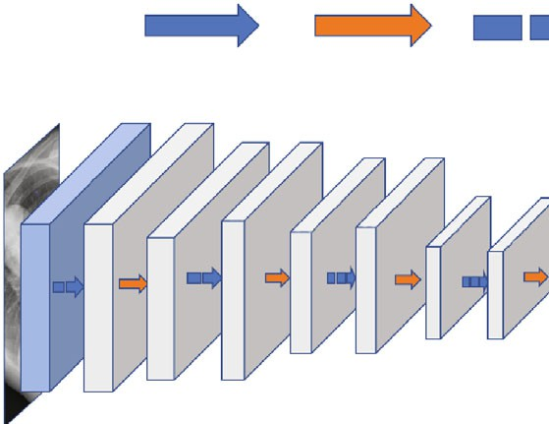
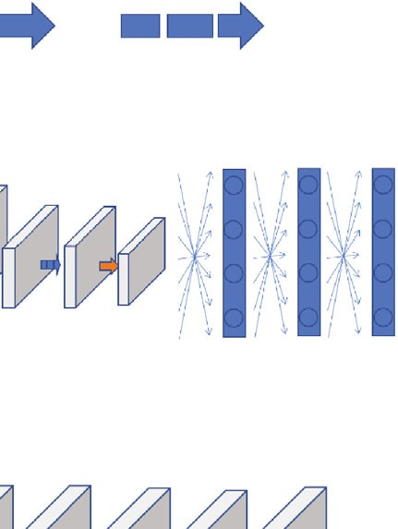
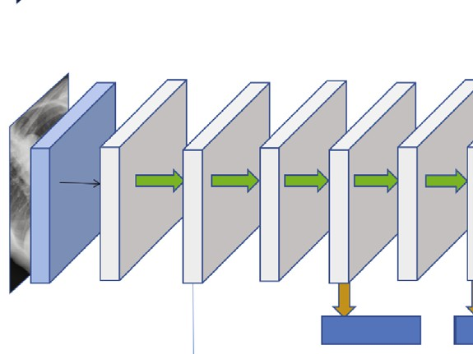
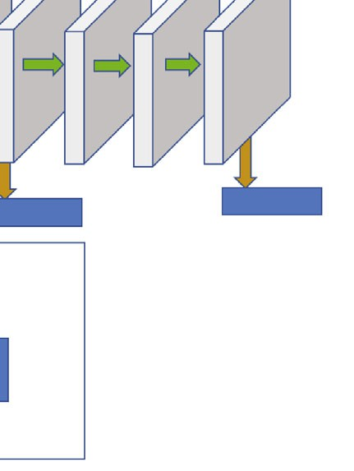
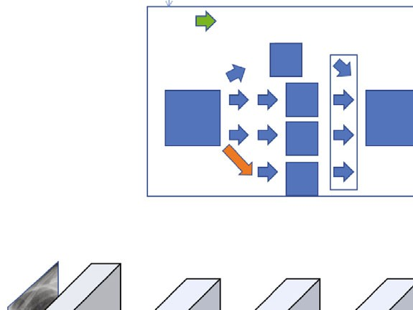
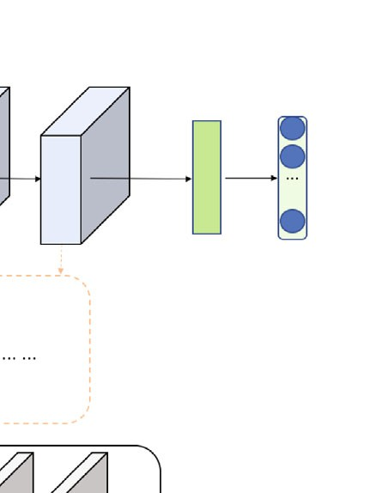
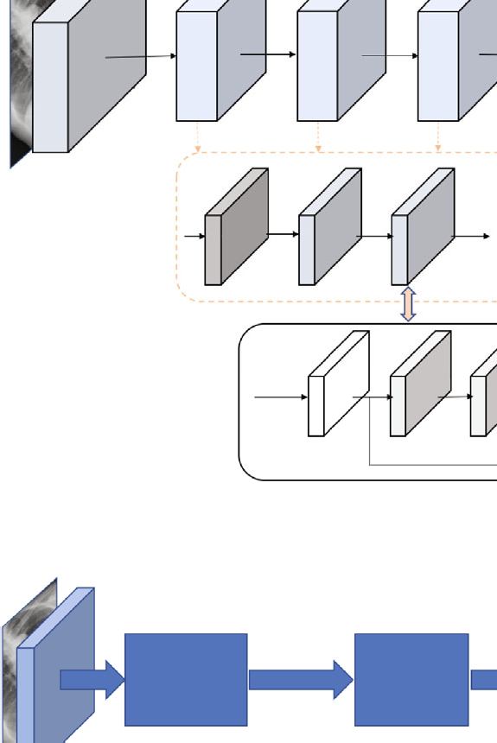
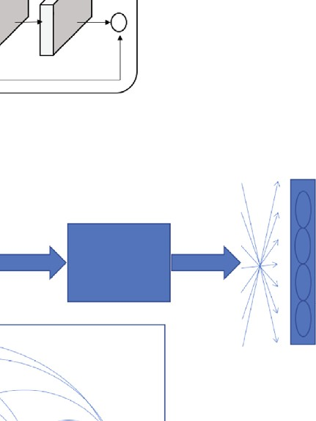
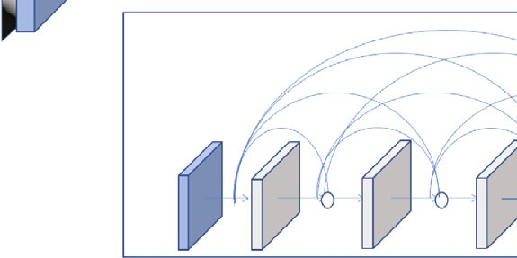
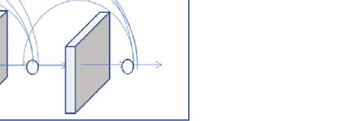
VGG 3⁎3 Conv Max pooling
512
244 224 112
112
56
56 28 28 14
14 7
4096 4096 Classes
(a)
Inception
3
224
224
Softmax0

Depth concat
a⁎a
⁎c1
a⁎a
Softmax1
Softmax2
Inception module
a⁎a⁎c

Max pooling
⁎c2
a⁎a
⁎c3
a⁎a
⁎c4
a⁎a⁎(c
1+c2+
c3+c4)
(b)
ResNet
Predictive probability
Input stem
Stage1
Stage2
Stage3
Stage4
Down Residual Residual
sample block block
w
w
w
w
h
Input
h
h
h
+
c
c′
c′
c
(c)
DenseNet
Conv
Conv+pooling
Conv+pooling
Pooling
DenseBlock1 DenseBlock2 DenseBlock3
DenseBlock
c
c
c
c

2⁎(3⁎3 Conv) 3⁎(3⁎3 Conv)

224 224 | 112 | 112 | 56 56
3 64 64 | 128 | 128 | 256 | 28  256 | 512 | 28 | 512 14 14 | 5127

(d)

Figure 2: Examples of CNN-based classification networks (original copy).

Here, we denote TP as true positives, FP as false pos- itives, FN as false negatives, TN as true negatives, and n as the number of the testing samples.
Downloaded from https://spj.science.org on November 05, 2025
Softmax
  - Object Detection for Medical Image Analysis. Generally speaking, object detection algorithms include both identifica- tion and localization tasks. The identification task refers to

judging whether objects belonging to certain classes appear in regions of interest (ROIs) whereas the localization task refers to localizing the position of the object in the image. In medical image analysis, detection is commonly aimed at detecting the earliest signs of abnormality in patients. Exem- plar clinical applications of detection tasks include lung nod- ule detection in chest CT or X-ray images [34, 35], lesion detection on CT images [36, 37], or mammograms [38].
Object detection algorithms can be categorized into two approaches, the anchor-based approach or anchor-free approach, where anchor-based algorithms can be further divided as single-stage algorithms or two/multistage algo- rithms. In general, single-stage algorithms are computation- ally efficient whereas two/multistage algorithms have better detection performance. The family of YOLO [39] and the single-shot multibox detector (SSD) [40] are two classic and widely used single-stage detectors with simple model archi- tectures. As shown in Figures 3(a) and 3(b), both architec- tures are based on feed-forward convolutional networks producing a fixed number of bounding boxes and their corre- sponding scores for the presence of object instances of given classes in the boxes. A nonmaximum suppression step is applied to generate the final predictions. Diﬀerent from YOLO which works on a single-scale feature map, the SSD utilizes multiscale feature maps, thereby producing better detection performance. Two-stage frameworks generate a set of ROIs and classify each of them through a network. The Faster-RCNN framework [41] and its descendant Mask-RCNN [42] are the most popular two-stage frame- works. As shown in Figure 3(c), the Faster/Mask-RCNN first generates object proposals through a region proposal net- work (RPN) and then classifies those generated proposals. The major diﬀerence between the Faster-RCNN and the Mask-RCNN is that the Mask-RCNN has an instance seg- mentation branch. Recently, there is a research trend on developing anchor-free algorithms. CornerNet [43] is one of the popular ones. As illustrated in Figure 3(d), CornerNet is a single convolutional neural network which eliminates the use of anchor boxes via utilizing paired key points where an
Since the fully convolutional neural network (FCN) [47] has been proposed, image segmentation has achieved great success. FCN was the first CNN which turned the classifica- tion task to dense segmentation task with in-network upsam- pling and a pixelwise loss. Through a skip architecture, it combined coarse, semantic, and local information to dense prediction. Medical image segmentation methods can be divided into two categories: the 2D methods and the 3D methods according to the input data dimension. The U- Net architecture [48] is the most popular FCN for medical image segmentation. As shown in Figure 4, U-Net consists of a contracting path (the downsample side) and an expansive path (the upsample side). The contracting path follows the typical CNN architecture. It consists of the repeated application of convolutions, each followed by ReLU and max pooling operation with stride for down- sampling. At each downsampling step, it also doubles the number of feature channels. Each step in the expansive path is composed of feature map upsampling followed by deconvolution that halves the number of feature channels; a concatenation with the correspondingly cropped feature map from the contracting path is also applied. Variants of U-Net-based architectures have been proposed. Isensee et al. [49] proposed a general framework called nnU-Net (No new U-Net) for medical image segmentation, which applied a dataset fingerprint (representing the key proper- ties of the dataset) and a pipeline fingerprint (representing the key design of the algorithms) to systematically opti- mize the segmentation task via formulating a set of heuris- tic rules from domain knowledge. The nnU-Net achieved state-of-the-art performance on 19 diﬀerent datasets with
49 segmentation tasks across a variety of organs, organ structures, tumors, and lesions in a number of imaging modalities (such as CT, MRI).
Dice similarity coefficient and intersection over union (IOU) are the two major evaluation metrics to evaluate the performance of segmentation methods, and they are defined as follows:

object bounding box is indicated by the top-left corner and the bottom-right corner.
There are two main metrics to evaluate the performance of detection methods: the mean average precision (mAP) and the false positive per image (FP/I @ recall). mAP is used
Dice = 2× TP , 2 × TP + FP + FN
TP
IOU = ,
TP + FP + FN

(2)

to calculate the average of all average precisions (APs) of all categories. FP/I @ recall rate is a measure of false positive (FP) of each image under a certain recall rate which takes into account the balance between false positives and the missing rate.
Downloaded from https://spj.science.org on November 05, 2025

  - Segmentation for Medical Image Analysis. Image segmen- tation is a pixel labeling problem, which partitions an image into regions with similar properties. For medical image anal- ysis, segmentation is aimed at determining the contour of an organ or anatomical structure in images. Segmentation tasks in clinical applications include segmenting a variety of organs, organ structures (such as the whole heart [44] and pancreas [45]), tumors, and lesions (such as the liver and liver tumor [46]) across diﬀerent medical imaging modalities.
where TP, FP, and FN denote true positive, false positive, and false negative, respectively.
  - Image Registration for Medical Image Analysis. Image registration, also known as image warping or image fusion, is a process of aligning two or more images. The goal of medical image registration is aimed at establishing optimal correspondence within images acquired at diﬀerent times (for longitudinal studies), by diﬀerent imaging modalities (such as CT, MRI), across diﬀerent patients (for intersub- ject studies), or from distinct viewpoints. Image registra- tion plays a crucial preprocessing step in many clinical applications including computer-aided intervention and treatment planning [50], image-guided/assisted surgery or simulation [51], and fusion of anatomical images (e.g.,

YOLO

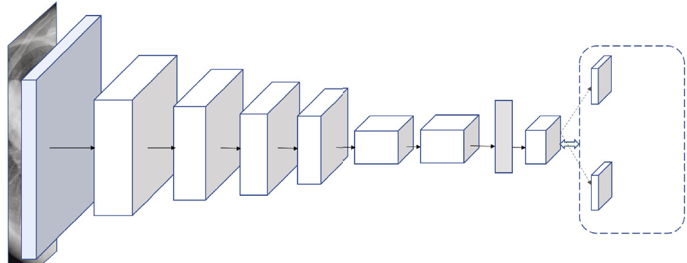
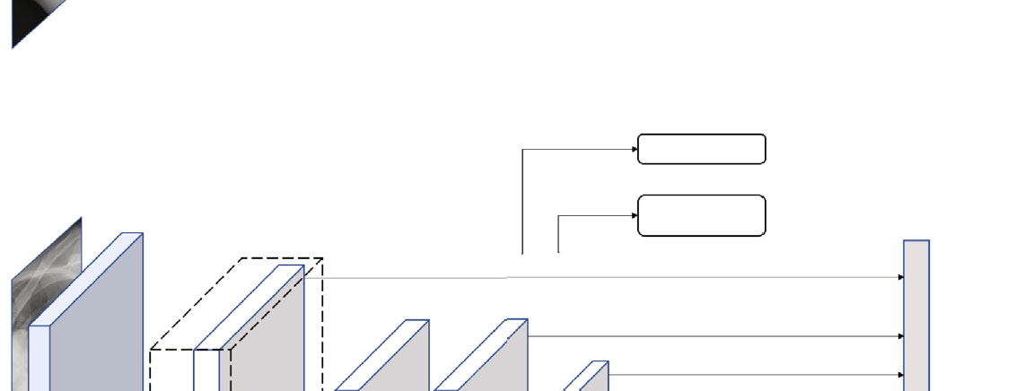
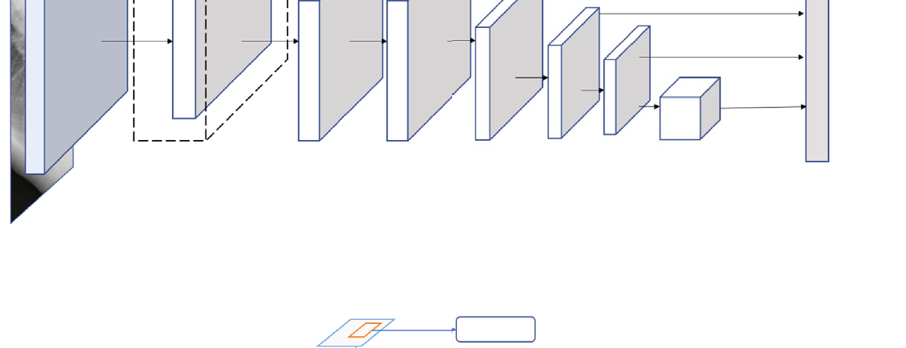
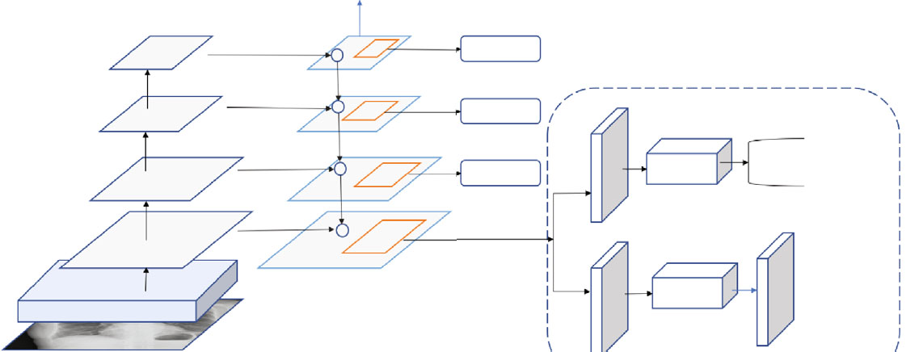
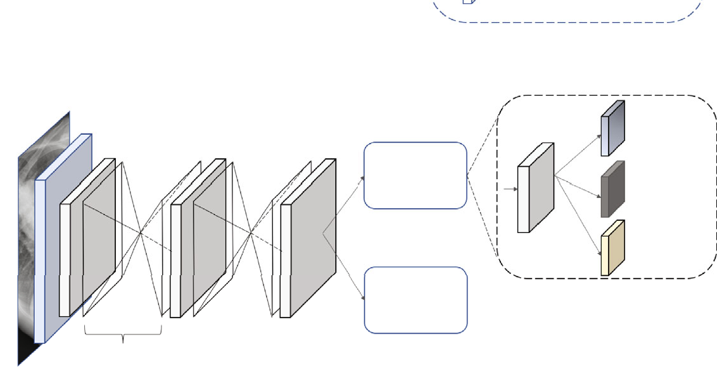
(d)
448
112
56
Classification
28 14
7
7
7
C
56
28 1024 14
1024
7
1024
7
4096
B⁎ 7
5+C
192
112
256 512
448
Bounding box regression
B⁎5
3
(a)
SSD
Classification
VGG-16
Bounding box regression
300
38
19 19
10
5
3
38
1
19
19
10
300
512
5 3
1
3
1024 1024 512 256 256 256

(b)
Mask-RCNN
Predict
C5
w
P5
+
Predict
Predict
C4
P4
+
Predict
C3
P3
+
Predict
fc
Classification

Bounding box regression
C2
P2
+
ROI align
Conv blocks
Convs
Mask
(c)
CornerNet
Top-left corners
Heatmaps
Prediction module
Corner pooling
Embeddings
Offsets
Prediction module
Hourglass module
Bottom-right corners
Figure 3: Examples of object detection frameworks (original copy).

CT or MRI images) with functional images (such as posi- tron emission tomography, single-photon emission com- puted tomography, or functional MRI) for disease diagnosis and monitoring [52].
Downloaded from https://spj.science.org on November 05, 2025
Detection: 8732 bounding boxes per class
Depending on diﬀerent points of view, image registration methodologies can be categorized diﬀerently. For instance, image registration methods can be classified as monomodal or multimodal based on imaging modalities involved. From

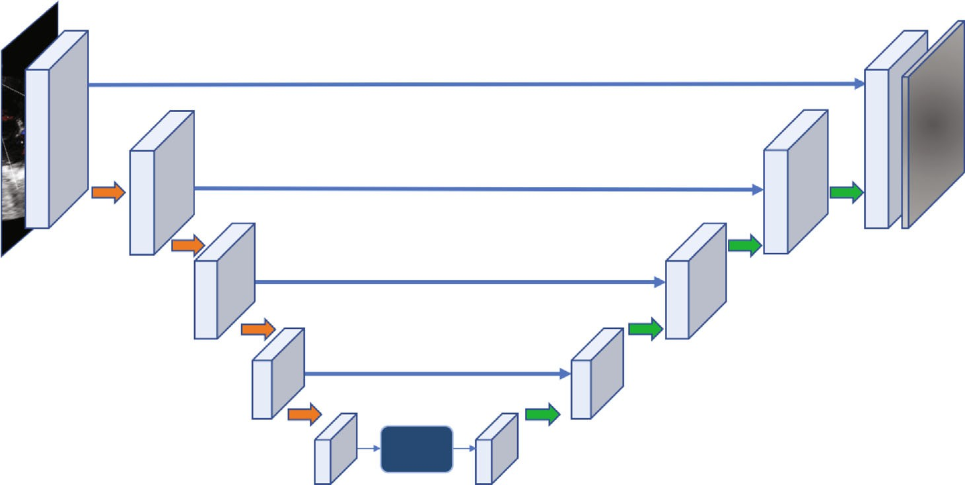
U-Net
Mask
Conv module
Upsample
Downsample
Figure 4: Examples of image segmentation frameworks (original copy).

the nature of geometric transformation, methods can also be categorized as rigid or nonrigid classes. By data dimensional- ity, registration methods can be classified as 2D/2D, 3D/3D, 2D/3D, etc., and from similarity measure point of view, reg- istration can be categorized as feature-based or intensity- based groups. Previously, image registration has been exten- sively explored as an optimization problem whose aim is to search the best geometric transformation iteratively through optimizing a similarity measure such as sum of squared dif- ferences (SSD), mutual information (MI), and cross- correlation (CC). Ever since the beginning of the deep learn- ing renaissance, various deep learning-based registration methods have been proposed and achieved the state-of-the- art performance [53].
Downloaded from https://spj.science.org on November 05, 2025
Yang et al. [54] proposed a fully supervised deep learning method to align 2D/3D intersubject brain MR in a single step via a U-Net-like FCN. Jun et al. [55] also applied a CNN to perform deformable registration of abdominal MR images to compensate respiration deformation. Despite the success of supervised learning-based methods, the nature of acquisition of reliable ground truth remains sig- nificantly challenging. Weakly supervised and/or unsuper- vised methods can eﬀectively alleviate the issue of lack of training datasets with ground truth. Li and Fan [56] trained an FCN to perform deformable 3D brain MR images using self-supervision. Inspired by the spatial transfer network (STN) [57], Kuang et al. [58] applied a STN-based CNN to perform deformable registration of MRI T1-W brain volumes.
Recently, Generative Adversarial Network- (GAN-) and Reinforcement Learning- (RL-) based methods have also motivated great attentions. Yan et al. [59] performed a rigid registration of 3D MR and ultrasound images. In their work, the generator was trained to estimate rigid transformation where the discriminator was used to distinguish between images that were aligned by ground-truth transformations or by predicted ones. Kreb et al. [60] applied a RL method to perform the nonrigid deformable registration of 2D/3D prostate MRI images where they utilized a low-resolution
deformation model for registration and a fuzzy action control to influence the action selection.
For performance evaluation, Dice coefficient and mean square error (MSE) are two major evaluation metrics. Target registration error (TRE) can also be applied if landmark cor- respondence can be acquired.

Clinical Applications
In this section, we review state-of-the-art clinical applications in four major systems of the human body involving the ner- vous system, the cardiovascular system, the digestive system, and the skeletal system. To be more specific, AI algorithms on medical image diagnostic analysis for the following representative diseases including brain diseases, cardiac dis- eases, and liver diseases, as well as orthopedic trauma, are discussed.
  - Brain. In this section, we discuss three most critical brain diseases, namely, stroke, intracranial hemorrhage, and intra- cranial aneurysm.
    - Stroke. Stroke is one of the leading causes of death and disability worldwide and imposes an enormous burden for health care systems [61]. Accurate and automatic segmenta- tion of stroke lesions can provide insightful information for neurologists.
Recent studies have presented tremendous ability in stroke lesion segmentation. Chen et al. [62] used DWI images as input to segment acute ischemic lesions and achieved an average Dice score of 0.67. Clèrigues et al. [63] proposed a deep learning methodology for acute and subacute stroke lesion segmentation using multimodal MRI images, and the Dice scores of the two segmentation tasks were 0.84 and 0.59, respectively. Liu et al. [64] used a U-shaped network (Res-CNN) to automatically segment acute ischemic stroke lesions from multimodality MRIs, and the average Dice coef- ficient was 0.742. Zhao et al. [65] proposed a semisupervised learning method using the weakly labeled subjects to detect

the suspicious acute ischemic stroke lesions and achieved a mean Dice coefficient of 0.642. Compared to using MRI, a 2D patch-based deep learning approach was proposed to seg- ment the acute stroke lesion core from CT perfusion images [66], and the average Dice coefficient was 0.49.
Downloaded from https://spj.science.org on November 05, 2025
    - Intracranial Hemorrhage. Recent studies have also shown great promise in automated detection of intracranial hemorrhage and its subtypes. Chilamkurthy et al. [67] achieved an AUC of 0.92 for detecting intracranial hemor- rhage based on a publicly available dataset called CQ500 con- sisting of 313,318 head CT scans from 20 centers. They use the original clinical radiology report and consensus of three independent radiologists as the gold standard to evaluate their method. Ye et al. [68] proposed a novel three- dimensional (3D) joint convolutional and recurrent neural network (CNN-RNN) for the detection of intracranial hem- orrhage. They developed and evaluated their method on a total of 2,836 subjects (ICH/normal, 1,836/1,000) from three institutions. Their algorithm achieved an AUC of 0.94 for intraparenchymal, 0.93 for intraventricular, 0.96 for sub- dural, 0.94 for extradural, and 0.89 for subarachnoid for the subtype classification task. Ker et al. [69] proposed to apply an image thresholding in the preprocessing step to improve the classification F1 score from 0.919 to 0.952 for their 3D CNN-based acute brain hemorrhage diagnosis. Singh et al.
[70] also proposed an image preprocessing method to improve the 3D CNN-based acute brain hemorrhage detec- tion via normalizing 3D volumetric scans using intensity profile. Their experimental results demonstrated the best F1 scores of 0.96, 0.93, 0.98, and 0.99, respectively, for four types of acute brain hemorrhages (i.e., subarachnoid, intrapar- enchymal, subdural, and intraventricular) on the CQ500 dataset [67].
    - Intracranial Aneurysm. Intracranial aneurysm is a common life-threatening disease usually caused by trauma, vascular disease, or congenital development with a preva- lence of 3.2% in the population [71]. Rupture of an intracra- nial aneurysm is a serious incident with high mortality and morbidity rates [72]. As such, the accurate detection of intra- cranial aneurysms is also important. Computed tomography angiography (CTA) and magnetic resonance angiography (MRA) are noninvasive methods and widely used for the diagnosis and presurgical planning of intracranial aneurysms [73]. Nakao et al. [74] used a CNN classifier to predict whether each voxel was inside or outside aneurysms by inputting MIP images generated from a volume of interest around the voxel. They detected 94.2% of aneurysms with
2.9 false positives per case. Stember et al. [75] employed a CNN based on U-Net architecture to detect aneurysms on MIP images and then to derive aneurysm size. Sichtermann et al. [76] established a system based on an open-source neu- ral network named DeepMedic for the detection of intracra- nial aneurysms from 3D TOF-MRA data. Ueda et al. [77] adopted ResNet for the detection of aneurysms from MRA images and reached a sensitivity of 91% and 93% for the internal and external test datasets, respectively. Allison et al.
- proposed a segmentation model called HeadXNet to
segment aneurysms on CTA images. Recently, Shi et al.
- proposed a 3D patch-based deep learning model for detecting intracranial aneurysm in CTA images. The pro- posed model utilized both spatial and channel attentions within a residual-based encoder-decoder architecture. Exper- imental results on multicohorta studies proofed the clinical applicability.
  - Cardiac/Heart. Echocardiography, CT, and MRI are commonly used medical imaging modalities for noninvasive assessment of the function and structure of the cardiovascu- lar system. Automatic analysis of images from the above modalities can help physicians study the structure and func- tion of heart muscle, find the cause of a patient’s heart failure, identify potential tissue damages, and so on.
    - Identification of Standard Scan Planes. Identification of standard scan planes is an important step in clinical echocar- diogram interpretation since many cardiac diseases are diag- nosed based on standard scan planes. Zhang et al. [80] built a fully automated, scalable, analysis pipeline for echocardio- gram interpretation, including view identification, cardiac chamber segmentation, quantification of structure and func- tion, and disease detection. They trained a 13-layer CNN on 14,035 echocardiograms spanning on a 10-year period for identification of 23 viewpoints and trained a cardiac chamber segmentation network across 5 common standard scan planes. Then, the segmentation output was used to quantify chamber volumes and LV mass, determine ejection fraction, and facilitate automated determination of longitudinal strain through speckle tracking. Howard et al. [81] trained a two- stream network on over 8,000 echocardiographic videos for
14 diﬀerent scan plane identification, which contained a time-distributed network to get spatial feature and a tempo- ral network to get optical flow feature of moving objects between frames. Experiments showed that the proposed method can halve the error rate for video scan plane classifi- cation, and the types of misclassification the method made were very similar to diﬀerences of opinion between human experts.
    - Segmentation of Cardiac Structures. Vigneault et al.
[82] presented a novel deep CNN architecture called Ω-Net for fully automatic whole-heart segmentation. The network was trained end to end from scratch to segment five fore-
ground classes (the four cardiac chambers plus the LV myo- cardium) in three views (SA, 4C, and 2C) with data acquired from both 1.5-T and 3-T magnets as part of a multicenter trial involving 10 institutions. Xiong et al. [83] developed a 16-layer CNN model called AtriaNet to automatically seg- ment the left atrial (LA) epicardium and endocardium. Atria- Net consists of a multiscaled dual-pathway architecture with two diﬀerent sizes of input patches centered on the same region that captures both the local arterial tissue and geome- try and the global positional information of LA. Benchmark- ing experiments showed that AtriaNet had outperformed the state-of-the-art CNNs, with a Dice score of 0.940 and 0.942 for the LA epicardium and endocardium at the time. Moccia et al. [84] modified and trained the ENet, a fully

convolutional neural network, to provide scar-tissue segmen- tation in the left ventricle. Bai et al. [85] proposed an image sequence segmentation algorithm by combining a fully con- volutional network with a recurrent neural network, which incorporated both spatial and temporal information into the segmentation task. The proposed method achieved an average Dice metric of 0.960 for the ascending aorta and 0.953 for the descending aorta. Morris et al. [86] developed a novel pipeline that paired MRI/CT data that were placed into separate image channels to train a 3D neural network using the entire 3D image for sensitive cardiac substructure segmentation. The paired MR/CT multichannel data inputs yielded robust segmentations on noncontrast CT inputs, and data augmentation and 3D Conditional Random Field (CRF) postprocessing improved deep learning contour agreement with ground truth.
Downloaded from https://spj.science.org on November 05, 2025

    - Coronary Artery Segmentation. Shen et al. [87] pro- posed a joint framework for coronary CTA segmentation based on deep learning and traditional-level set method. A 3D FCN was used to learn the 3D semantic features of coro- nary arteries. Moreover, an attention gate was added to the entire network, aiming to enhance the vessels and suppress irrelevant regions. The output of 3D FCN with the attention gate was optimized by the level set to smooth the boundary to better fit the ground-truth segmentation. The coronary CTA dataset used in this work consisted of 11,200 CTA images from 70 groups of patients, of which 20 groups of patients were used as a test set. The proposed algorithm provided sig- nificantly better segmentation results than vanilla 3D FCN intuitively and quantitatively. He et al. [88] developed a novel blood vessel centerline extraction framework utilizing a hybrid representation learning approach. The main idea was to use CNNs to learn local appearances of vessels in image crops while using another point-cloud network to learn the global geometry of vessels in the entire image. This combination resulted in an efficient, fully automatic, and template-free approach to centerline extraction from 3D images. The proposed approach was validated on CTA data- sets and demonstrated its superior performance compared to both traditional and CNN-based baselines.

    - Coronary Artery Calcium and Plaque Detection. Zhang et al. [89] established an end-to-end learning framework for artery-specific coronary calcification identification in non- contrast cardiac CT, which can directly yield accurate results based on given CT scans in the testing process. In this frame- work, the intraslice calcification features were collected by a 2D U-DenseNet, which was the combination of DenseNet and U-Net. While those lesions spanned multiple adjacent slices, authors performed 3D U-Net extraction to the inter- slice calcification features, and the joint semantic features of 2D and 3D modules were beneficial to artery-specific calcifi- cation identification. The proposed method was validated on 169 noncontrast cardiac CT exams collected from two cen- ters by cross-validation and achieved a sensitivity of 0.905, a PPV of 0.966 for calcification number, a sensitivity of 0.933, a PPV of 0.960, and a F₁ score of 0.946 for calcification volume, respectively. Liu et al. [90] proposed a vessel-focused
3D convolutional network for automatic segmentation of artery plaque including three subtypes: calcified plaques, noncalcified plaques, and mixed calcified plaques. They first extracted the coronary arteries from the CT volumes and then reformed the artery segments into straightened vol- umes. Finally, they employed a 3D vessel-focused convolu- tional neural network for plaque segmentation. This proposed method was trained and tested on a dataset of mul- tiphase CCTA volumes of 25 patients. The proposed method achieved Dice scores of 0.83, 0.73, and 0.68 for calcified pla- ques, noncalcified plaques, and mixed calcified plaques, respectively, on the test set, which showed a potential value for clinical application.
  - Liver. CT and MRI are widely used for the early detec- tion, diagnosis, and treatment of liver diseases. Automatic segmentation of the liver and/or liver lesion with CT or MRI is of great importance in radiotherapy planning, liver transplantation planning, and so on.
    - Liver Lesion Detection and Segmentation. Vorontsov et al. used deep CNNs to detect and segment liver tumors [91]. For lesion sizes smaller than 10 mm (n = 30), 10–20 mm (n = 35), and larger than 20 mm (n = 40), the detection sensitivities of the method were 10%, 71%, and 85%; positive predictive values were 25%, 83%, and 94%;
and dice similarity coefficients were 0.14, 0.53, and 0.68. Wang et al. proposed an attention network by using an extra network to gather information from continuous slices for lesion segmentation [92]. This method had a Dice per case score of 74.1% on LiTS test dataset. In order to improve the performance on small lesions, modified U-Net (mU-Net) is proposed by Seo et al. which obtained a Dice score of 89.72% on validation set for liver tumor segmentation [93]. An edge enhanced network was proposed by Tang et al.
[94] for liver tumor segmentation with a Dice per case score of 74.8% on LiTS test dataset.
    - Liver Lesion Classification. Unlike liver lesion segmen- tation or detection, there are few works about lesion classifi- cation, as there is no public dataset about lesion classification, and it is difficult to collect enough data. A liver tumor classi- fication system trained with 1,210 patients and validated in 201 patients based on deep learning was proposed by Zhen et al. [95]. The system can distinguish malignant from benign liver tumors with an AUC score of 94.6% using only unen- hanced images, and the performance can be improved a lot with clinical information.
    - Liver Fibrosis Staging. Liver fibrosis staging is impor- tant for the prevention and treatment of chronic liver disease. Although the amount of the works based on deep learning for liver fibrosis staging is few, these methods have shown their capability for this task. Liu et al. proposed a method using CNNs and SVM to classify the capsules on ultrasound images to get the stage score, and this method had a classification AUC score of 97.03% [96]. Yasaka et al. proposed two deep CNNs models to obtain stage scores, respectively, from CT
[97] and MRI [98] images, achieving AUC scores of 0.73-0.76 and 0.84-0.85, respectively. Choi et al. trained a

Table 1: Publicly available Benchmark datasets.

Dataset name | Organ/modalities | Image size | No. classes | No. of cases | Tasks | Resources
LIDC-IDRI | Lung/CT | 133 × 512 × 512 | 3 | 1018 | Lung nodules | [114]
LUNA | Lung/CT | 133 × 512 × 512 | 1 | 888 | Lung nodules | [115]
DDSM | Breast/mammography | — | 3 | 2,500 | Breast mass | [116]
DeepLesion | Diversity CT | — | 3+ | 4427 | Lung nodules, liver tumors, lymph nodes | [117]
LiTS | Liver/CT | 432 × 512 × 512 | 2 | 131 | Liver, liver tumors | [118]
Brain tumor | Brain/MRI | 138 × 169 × 138 | 3 | 484 | Edema, tumor, necrosis | [119]
Heart | Heart/MRI | 115 × 320 × 232 | 1 | 20 | Left ventricle | [119]
Prostate | Prostate/MRI | 20 × 320 × 319 | 2 | 32 | Peripheral and transition zone | [119]
Pancreas | Pancreas/CT | 93 × 512 × 512 | 2 | 282 | Pancreas, pancreas cancer | [119]
Spleen | Spleen/CT | 90 × 512 × 512 | 1 | 41 | Spleen | [119]
Colon | Colon/CT | 95 × 512 × 512 | 1 | 126 | Colon cancer | [119]

model based on deep learning using 7,491 patients and validated on 891 patients, and the AUC score on the val- idation dataset was 0.95-0.97 [99]. Recently, a model based on multimodal ultrasound images received an AUC score of 0.93-0.95 [100] which used transfer learning to improve the classification performance.
Downloaded from https://spj.science.org on November 05, 2025
    - Other Liver Disease. Prediction of microvascular inva- sion (MVI) before surgery is valuable for liver cancer patients’ treatment planning since MVI is an adverse prog- nostic factor for these patients [101]. Men et al. proposed 3D CNNs with LSTM to predict MVI on enhanced MRI images receiving an AUC score of 89% [102]. Jiang et al.
[103] also reported a 3D CNN-based one with enhanced CT images achieving an AUC score of 90.6%.
  - Bone. Bone fracture, also called orthopedic trauma, is a relatively common disease. Bone fracture recognition in X-ray images has become a promising research direction since 2017 with the development of deep learning technol- ogy. In general, there are two main approaches for bone frac- ture recognition, namely, the classification-based approach and the object detection-based approach.
    - Classification-Based Approach. For the classification- based approach, researchers usually use the labels of “no fracture” and “fracture” for the whole image. The pioneer and dedicated work of the classification pipeline was from Olczak et al. [104]. By adopting the VGGNet as the back- bone of the classification pipeline, they trained the model on 256,000 well-labeled images of the wrists, hands, and ankles for recognizing fractures. With a large amount of validating data, the model set a strong and credible base- line of the accuracy of 83%. Urakawa et al. [105] used the same network architecture as Olczak et al.’s in classify- ing intertrochanteric hip fractures on 3,346 radiographs. The results have shown a 95.5% accuracy whereas an accuracy of orthopedic surgeons was reported at 92.2%. Gale et al. [106] extracted 53,000 clinical X-rays to get an area under the ROC curve of 0.994 whereas Krogue et al. [107] labeled 3,034 images to get an area under the
curve of 0.973. They both applied DenseNet into the classification task on hip fracture radiographs.
    - Object Detection-Based Approach. The object detection-based approach is aimed at localizing the fracture locations in the images. Gan et al. [108] trained a Faster R-CNN model to locate the area of wrist fracture; then, they sent the ROI to an inception framework for classifica- tion. The AUC score achieved 0.96 overpassing radiolo- gists’ performance by 9% in accuracy on a set of 2,340 anteroposterior wrist radiographs. Thian et al. [109] employed the same Faster R-CNN architecture and also ran the model on wrist radiographs with a larger volume of the dataset of 7,356 images. The result had an indistinc- tive AUC score of 0.957. Still on wrist radiographs, using the idea of semantic segmentation, Lindsey et al. [110] adopted an extension of U-Net to predict a heat map probability of fractures for each image pixel. Even using 135,409 wrist radiographs, the article only reported an average clinician sensitivity of 91.5% and specificity of 93.9% aided with a trained model, which seemed to be inferior to the above research. Wu et al. [111] proposed an end-to-end multidomain facture detection network which treated each body part as a domain. The proposed network was composed of two subnetworks, namely, a domain classification network for predicting the domain type of an image and a fracture detection network for detecting fractures on X-ray images of diﬀerent domains. By constructing feature enhancement modules and multifeature-enhanced r-CNN, the proposed network extracted more representative features for each domain. Experimental results on real-clinical data demonstrated the eﬀectiveness with the best F-score on all the domains over existing Faster R-CNN-based state-of-the-art methods. Recently, Wu et al. [112] proposed a novel fea- ture ambiguity mitigation model to improve the bone frac- ture detection on X-ray radiographs. A total of 9,040 radiographic images for various body parts including the hand, wrist, elbow, shoulder, pelvic, knee, ankle, and foot were studied. Experimental results demonstrated perfor- mance improvements in all body parts.

Challenges and Future Directions
Downloaded from https://spj.science.org on November 05, 2025
Although deep learning models have achieved great success in medical image analysis, small-scale medical datasets are still the main bottleneck in this field. Inspired by the idea of transfer learning technique, one possible way is to do domain transfer which adapts a model trained on natural images to medical image applications or from one image modality to another. Another possible way is to apply federated learning
[113] by which training can be performed among multiple data centers collaboratively. In addition, researchers have also begun to collect benchmark datasets for various medical image analysis purposes. Table 1 summarized examples of the publicly available datasets.
Class imbalance is another major problem of medical image analysis. A number of researches on novel loss func- tion design, such as focal loss [120], grading loss [121], contrastive loss [122], and triplet loss [123], have been pro- posed to tackle this problem. Making use of domain subject knowledge is another direction. For instance, Jiménez- Sánchez et al. [124] proposed a curriculum learning method to classify proximal femoral fractures in X-ray images, whose core idea is to control the sampling weight of sam- ples in the training process based on a priori knowledge. Chen et al. [125] also proposed a novel pelvic fracture detection framework based on bilaterally symmetric struc- ture assumption.

Conclusion
The rise of advanced deep learning methods has enabled great success in medical image analysis with high accuracy, efficiency, stability, and scalability. In this paper, we reviewed the recent progress of CNN-based deep learning techniques in clinical applications including image classification, object detection, segmentation, and registration. More detailed image analysis-based diagnostic applications in four major systems of the human body involving the nervous system, the cardiovascular system, the digestive system, and the skel- etal system were reviewed. To be more specific, state-of-the- art works for diﬀerent diseases including brain diseases, cardiac diseases, and liver diseases, as well as orthopedic trauma, are discussed. This paper also described the existing problems in the field and provided possible solutions and future research directions.

Conflicts of Interest
The authors have completed and submitted the ICMJE Form for Disclosure of Potential Conflicts of Interest. The authors have no conflicts of interest to declare.

Authors’ Contributions
Y. Yu and X. Liu conceptualized, organized, and revised the manuscript. X. Liu contributed to all aspects of the preparation of the manuscript. K. Gao, B. Liu, C. Pan, K. Liang, L. Yan, J. Ma, F. He, S. Pan, and S. Zhang were involved in the writing of the manuscript. All authors con-
tributed to this paper. Xiaoqing Liu, Kunlun Gao, Bo Liu, Chengwei Pan, Kongming Liang, and Lifeng Yan contributed equally to this work.

Acknowledgments
This study was supported in part by grants from the Zhejiang Provincial Key Research & Development Program (No. 2020C03073).

References
- H. T. Shen, X. Zhu, Z. Zhang et al., “Heterogeneous data fusion for predicting mild cognitive impairment conversion,” Information Fusion, vol. 66, pp. 54–63, 2021.
- Y. Zhu, M. Kim, X. Zhu, D. Kaufer, and G. Wu, “Long range early diagnosis of Alzheimer's disease using longitudinal MR imaging data,” Medical Image Analysis, vol. 67, p. 101825, 2021.
- X. Zhu, B. Song, F. Shi et al., “Joint prediction and time esti- mation of COVID-19 developing severe symptoms using chest CT scan,” Medical Image Analysis, vol. 67, p. 101824, 2021.
- S. Mitra and B. Uma Shankar, “Medical image analysis for cancer management in natural computing framework,” Infor- mation Sciences, vol. 306, pp. 111–131, 2015.
- E. Miranda, M. Aryuni, and E. Irwansyah, “A survey of med- ical image classification techniques,” in 2016 International Conference on Information Management and Technology (ICIMTech), Bandung, Indonesia, 2016.
- D. Shen, G. Wu, and H.-I. Suk, “Deep learning in medical image analysis,” Annual Review of Biomedical Engineering, vol. 19, no. 1, pp. 221–248, 2017.
- K. Suzuki, “Survey of deep learning applications to medical image analysis,” Medical Imaging Technology, vol. 35,
pp. 212–226, 2017.
- S. K. Zhou, H. Greenspan, and D. Shen, Deep Learning for Medical Image Analysis, Academic Press, 2017.
- J. Ker, L. Wang, J. Rao, and T. Lim, “Deep learning applica- tions in medical image analysis,” IEEE Access, vol. 6,
pp. 9375–9389, 2018.
- S. Liu, Y. Wang, X. Yang et al., “Deep learning in medical ultrasound analysis: a review,” Engineering, vol. 5, no. 2,
pp. 261–275, 2019.
- A. Maier, C. Syben, and T. Lasser, “A gentle introduction to deep learning in medical image processing,” Zeitschrift für Medizinische Physik, vol. 29, pp. 86–101, 2019.
- G. Litjens, T. Kooi, B. E. Bejnordi et al., “A survey on deep learning in medical image analysis,” Medical Image Analysis, vol. 42, pp. 60–88, 2017.
- S. P. Singh, L. Wang, S. Gupta, H. Goli, P. Padmanabhan, and
B. Gulyás, “3D deep learning on medical images: a review,”
Sensors, vol. 20, no. 18, article 5097, 2020.
- S. Yadav and S. Jadhav, “Deep convolutional neural network based medical image classification for disease diagnosis,” Journal of Big Data, vol. 6, no. 1, p. 113, 2019.
- C. Wang, F. Zhang, Y. Yu, and Y. Wang, “BR-GAN: bilateral residual generating adversarial network for mammogram classification,” in Medical Image Computing and Computer Assisted Intervention – MICCAI 2020. MICCAI 2020, A. L.

Martel, Ed., vol. 12262 of Lecture Notes in Computer Science, Springer, Cham, 2020.
Downloaded from https://spj.science.org on November 05, 2025
- A. Esteva, B. Kuprel, R. A. Novoa et al., “Dermatologist-level classification of skin cancer with deep neural networks,” Nature, vol. 542, no. 7639, pp. 115–118, 2017.
- H. Wu, H. Yin, H. Chen et al., “A deep learning, image based approach for automated diagnosis for inflammatory skin dis- eases,” Annals of Translational Medicine, vol. 8, no. 9, p. 581, 2020.
- D. S. W. Ting, C. Y. L. Cheung, G. Lim et al., “Development and validation of a deep learning system for diabetic retinop- athy and related eye diseases using retinal images from mul- tiethnic Populations with diabetes,” JAMA, vol. 318, no. 22,
pp. 2211–2223, 2017.
- V. Gulshan, L. Peng, M. Coram et al., “Development and val- idation of a deep learning algorithm for detection of diabetic retinopathy in retinal fundus photographs,” JAMA, vol. 316, no. 22, pp. 2402–2410, 2016.
- X. Bai, S. I. Niwas, W. Lin et al., “Learning ECOC code matrix for multiclass classification with application to glaucoma diagnosis,” Journal of Medical Systems, vol. 40, no. 4, 2016.
- H. Gu, Y. Guo, L. Gu et al., “Deep learning for identifying corneal diseases from ocular surface slit-lamp photographs,” Scientific Reports, vol. 10, no. 1, p. 17851, 2020.
- F. A. Spanhol, L. S. Oliveira, P. R. Cavalin, C. Petitjean, and
L. Heutte, “Deep features for breast cancer histopathological image classification,” in 2017 IEEE International Conference on Systems, Man, and Cybernetics (SMC), pp. 1868–1873, Banﬀ, AB, Canada, 2017.
- J. Ker, Y. Bai, H. Y. Lee, J. Rao, and L. Wang, “Automated brain histology classification using machine learning,” Jour- nal of Clinical Neuroscience, vol. 66, pp. 239–245, 2019.
- D. Ciresan, U. Meier, and J. Schmidhuber, “Multi-column deep neural networks for image classification,” in 2012 IEEE Conference on Computer Vision and Pattern Recognition,
pp. 3642–3649, Providence, RI, USA, 2012.
- A. Krizhevsky, I. Sutskever, and G. E. Hinton, “Imagenet classification with deep convolutional neural networks,” Communications of the ACM, vol. 60, no. 6, pp. 84–90, 2017.
- K. Simonyan and A. Zisserman, Very deep convolutional net- works for large-scale image recognition, Computer, Interna- tional Conference on Learning Representations, San Diego, CA, USA, 2014.
- C. Szegedy, W. Liu, Y. Jia et al., “Going deeper with convolu- tions,” in 2015 IEEE Conference on Computer Vision and Pat- tern Recognition (CVPR), pp. 1–9, Boston, MA, USA, 2015.
- C. Szegedy, V. Vanhoucke, S. Ioﬀe, J. Shlens, and Z. Wojna, “Rethinking the inception architecture for computer vision,” 2015, https://arxiv.org/abs/1512.00567.
- C. Szegedy, S. Ioﬀe, V. Vanhoucke, and A. Alemi, “Inception- v4, inception-resnet and the impact of residual connections on learning,” 2016, https://arxiv.org/abs/1602.07261.
- K. He, X. Zhang, S. Ren, and J. Sun, “Deep residual learning for image recognition,” in 2016 IEEE Conference on Com- puter Vision and Pattern Recognition (CVPR), Las Vegas, NV, USA, 2016.
- G. Huang, Z. Liu, L. Van Der Maaten, and K. Q. Weinberger, “Densely connected convolutional networks,” in 2017 IEEE Conference on Computer Vision and Pattern Recognition (CVPR), Honolulu, HI, USA, 2017.
- J. Hu, L. Shen, and G. Sun, “Squeeze-and-Excitation Net- works,” in 2018 IEEE/CVF Conference on Computer Vision and Pattern Recognition (CVPR), Salt Lake City, Utah, USA, 2018.
- M. Tan and Q. V. Le, “EfficientNet: Rethinking Model Scaling for Convolutional Neural Networks,” in Proceedings of the 36th International Conference on Machine Learning,
pp. 6105–6114, Long Beach, California, USA, 2019.
- S.-C. B. Lo, S.-L. A. Lou, J.-S. Lin, M. T. Freedman, M. V.
Chien, and S. K. Mun, “Artificial convolution neural network techniques and applications for lung nodule detection,” IEEE Transactions on Medical Imaging, vol. 14, no. 4, pp. 711–718, 1995.
- J. Liu, G. Zhao, F. Yu, M. Zhang, Y. Wang, and Y. Yizhou, “Align, attend and locate: chest x-ray diagnosis via contrast induced attention network with limited supervision,” in 2019 IEEE/CVF International Conference on Computer Vision (ICCV), pp. 10632–10641, Seoul, Korea, 2019.
- Z. Li, S. Zhang, J. Zhang, K. Huang, Y. Wang, and Y. Yizhou, “MVP Net: multi-view FPN with position-aware attention for deep universal lesion detection,” in Medical Image Comput- ing and Computer Assisted Intervention – MICCAI 2019. MICCAI 2019, D. Shen, Ed., vol. 11769 of Lecture Notes in Computer Science, Springer, Cham, 2019.
- S. Zhang, J. Xu, Y.-C. Chen et al., “Revisiting 3D context modeling with supervised pre-training for universal lesion detection in CT slices,” in Medical Image Computing and Computer Assisted Intervention – MICCAI 2020. MICCAI 2020, A. L. Martel, Ed., vol. 12264 of Lecture Notes in Com- puter Science, Springer, Cham, 2020.
- Y. Liu, F. Zhang, Q. Zhang, S. Wang, Y. Wang, and Y. Yizhou, “Cross-view correspondence reasoning based on bipartite graph convolutional network for mammogram mass detec- tion,” in 2020 IEEE/CVF Conference on Computer Vision and Pattern Recognition (CVPR), Seattle, WA, USA, June 2020.
- J. Redmon, S. Divvala, R. Girshick, and A. Farhadi, “You only look once: unified, real-time object detection,” in Proceedings of the IEEE conference on computer vision and pattern recog- nition, pp. 779–788, 2016.
- W. Liu, D. Anguelov, D. Erhan et al., “SSD: single shot Multi- Box detector,” in Computer Vision – ECCV 2016. ECCV 2016, vol. 9905 of Lecture Notes in Computer Science, Springer, Cham.
- S. Ren, K. He, R. Girshick, and J. Sun, “Faster R-CNN: towards real-time object detection with region proposal net- works,” IEEE Transactions on Pattern Analysis and Machine Intelligence, vol. 39, no. 6, pp. 1137–1149, 2017.
- G. Gkioxari, P. Dollar, and R. Girshick, “Mask R-CNN,” in Proceedings of the IEEE International Conference on Com- puter Vision (ICCV), pp. 2961–2969, 2017.
- H. Law, “CornerNet: detecting objects as paired keypoints,” in Computer Vision – ECCV 2018. ECCV 2018, V. Ferrari,
M. Hebert, C. Sminchisescu, and Y. Weiss, Eds., vol. 11218 of Lecture Notes in Computer Science, pp. 765–781, Springer, Cham, 2018.
- C. Ye, W. Wang, S. Zhang, and K. Wang, “Multi-depth fusion network for whole-heart CT image segmentation,” IEEE Access, vol. 7, pp. 23421–23429, 2019.
- C. Fang, G. Li, C. Pan, Y. Li, and Y. Yizhou, “Globally guided progressive fusion network for 3D pancreas segmentation,” in Medical Image Computing and Computer Assisted

Intervention – MICCAI 2019. MICCAI 2019, D. Shen, Ed., vol. 11765 of Lecture Notes in Computer Science, Springer, Cham, 2019.
Downloaded from https://spj.science.org on November 05, 2025
- X. Li, H. Chen, X. Qi, Q. Dou, C. W. Fu, and P. A. Heng, “H-DenseUNet: hybrid densely connected UNet for liver and tumor segmentation from CT volumes,” IEEE Transactions on Medical Imaging, vol. 37, no. 12, pp. 2663–2674, 2018.
- J. Long, E. Shelhamer, and T. Darrell, “Fully convolutional networks for semantic segmentation,” IEEE trans Pattern Anal Mach Intel, vol. 39, no. 4, pp. 640–651, 2014.
- O. Ronneberger, P. Fischer, and T. Brox, “U-Net: Convolu- tional networks for biomedical image segmentation,” in Medical Image Computing and Computer-Assisted Interven- tion – MICCAI 2015. MICCAI 2015, N. Navab, J. Hornegger,
W. Wells, and A. Frangi, Eds., vol. 9351 of Lecture Notes in Computer Science, Springer, Cham, 2015.
- F. Isensee, P. F. Jaeger, S. A. A. Kohl, J. Petersen, and K. H. Maier-Hein, “Automated design of deep learning methods for biomedical image segmentation,” https://arxiv.org/abs/ 1904.08128.
- M. Staring, U. A. van der Heide, S. Klein, M. A. Viergever, and J. Pluim, “Registration of cervical MRI using multifeature mutual information,” IEEE Transactions on Medical Imaging, vol. 28, no. 9, pp. 1412–1421, 2009.
- K. Miller, A. Wittek, G. Joldes et al., “Modelling brain deformations for computer‐integrated neurosurgery,” Inter- national Journal for Numerical Methods in Biomedical Engineering, vol. 26, no. 1, pp. 117–138, 2010.
- Xishi Huang, Jing Ren, G. Guiraudon, D. Boughner, and T. M. Peters, “Rapid dynamic image registration of the beating heart for diagnosis and surgical navigation,” IEEE Transactions on Medical Imaging, vol. 28, no. 11, pp. 1802–1814, 2009.
- G. Haskins, U. Kruger, and P. Yan, “Deep learning in medical image registration: a survey,” Machine Vision and Applica- tions, vol. 31, no. 1-2, 2020.
- X. Yang, R. Kwitt, and M. Niethammer, “Fast predictive image registration,” Deep Learning and Data Labeling for Medical Applications., pp. 48–57, 2016.
- J. Lv, M. Yang, J. Zhang, and X. Wang, “Respiratory motion correction for free-breathing 3D abdominal MRI using CNN-based image registration: a feasibility study,” The British Journal of Radiology, vol. 91, 2018.
- H. Li and Y. Fan, “Non-rigid image registration using self- supervised fully convolutional networks without training data,” in 2018 IEEE 15th International Symposium on Bio- medical Imaging (ISBI 2018), pp. 1075–1078, Washington, DC, USA, 2018.
- M. Jaderberg, K. Simonyan, A. Zisserman, and
K. Kavukcuoglu, “Spatial transfer networks,” Advances in Neural Information Processing Systems, vol. 28, pp. 2017– 2025, 2015.
- D. Kuang and T. Schmah, “FAIM-a ConvNet method for unsupervised 3D medical image registration,” 2018, https:// arxiv.org/abs/1811.09243.
- P. Yan, S. Xu, A. R. Rastinehad, and B. J. Wood, “Adversarial image registration with application for MR and TRUS image fusion,” 2018, https://arxiv.org/abs/1804.11024.
- J. Kreb, T. Mansi, H. Delingette et al., “Robust non-rigid reg- istration through agent-based action learning,” in Medical Image Computing and Computer Assisted Intervention − MICCAI 2017. MICCAI 2017, M. Descoteaux, L. Maier-Hein,
A. Franz, P. Jannin, D. Collins, and S. Duchesne, Eds., vol. 10433 of Lecture Notes in Computer Science, pp. 344– 352, Springer, Cham, 2017.
- M. Katan and A. Luft, “Global burden of stroke,” Seminars in Neurology, vol. 38, no. 2, p. 208, 2018.
- L. Chen, P. Bentley, and D. Rueckert, “Fully automatic acute ischemic lesion segmentation in dwi using convolutional neural networks,” Neuroimage Clin, vol. 15, pp. 633–643, 2017.
- A. Clèrigues, S. Valverde, J. Bernal, J. Freixenet, A. Oliver, and
X. Lladó, “Acute and sub-acute stroke lesion segmentation from multimodal MRI,” Computer Methods and Programs in Biomedicine, vol. 194, article 105521, 2020.
- L. Liu, S. Chen, F. Zhang, F. X. Wu, Y. Pan, and J. Wang, “Deep convolutional neural network for automatically seg- menting acute ischemic stroke lesion in multi-modality MRI,” Neural Computing and Applications, vol. 32, no. 11,
pp. 6545–6558, 2020.
- B. Zhao, S. Ding, H. Wu et al., “Automatic acute ischemic stroke lesion segmentation using semi-supervised learning,” 2019, https://arxiv.org/abs/1908.03735.
- A. Clèrigues, S. Valverde, J. Bernal, J. Freixenet, A. Oliver, and
X. Lladó, “Acute ischemic stroke lesion core segmentation in CT perfusion images using fully convolutional neural net- works,” Computers in Biology and Medicine, vol. 115, article 103487, 2019.
- S. Chilamkurthy, “Deep learning algorithms for detection of critical findings in head CT scans: a retrospective study,” The Lancet, vol. 392, no. 10162, pp. 2388–2396, 2018.
- H. Ye, F. Gao, Y. Yin et al., “Precise diagnosis of intracranial hemorrhage and subtypes using a three-dimensional joint convolutional and recurrent neural network,” European Radiology, vol. 29, no. 11, pp. 6191–6201, 2019.
- J. Ker, S. P. Singh, Y. Bai, J. Rao, T. Lim, and L. Wang, “Image thresholding improves 3-dimensional convolutional neural net- work diagnosis of diﬀerent acute brain hemorrhages on com- puted tomography scans,” Sensors, vol. 19, no. 9, p. 2167, 2019.
- S. Singh, L. Wang, S. Gupta, B. Gulyas, and P. Padmanabhan, “Shallow 3D CNN for detecting acute brain hemorrhage from medical imaging sensors,” IEEE Sensors Journal, p. 1, 2020.
- M. H. Vlak, A. Algra, R. Brandenburg, and G. J. E. Rinkel, “Prevalence of unruptured intracranial aneurysms, with emphasis on sex, age, comorbidity, country, and time period: a systematic review and meta-analysis,” Lancet Neurology, vol. 10, no. 7, pp. 626–636, 2011.
- D. J. Nieuwkamp, L. E. Setz, A. Algra, F. H. H. Linn, N. K. de Rooij, and G. J. E. Rinkel, “Changes in case fatality of aneu- rysmal subarachnoid haemorrhage over time, according to age, sex, and region: a meta-analysis,” The Lancet Neurology, vol. 8, no. 7, pp. 635–642, 2009.
- N. Turan, R. A. Heider, A. K. Roy et al., “Current perspectives in imaging modalities for the assessment of unruptured intra- cranial aneurysms: a comparative analysis and review,” World Neurosurgery, vol. 113, pp. 280–292, 2018.
- T. Nakao, S. Hanaoka, Y. Nomura et al., “Deep neural network-based computer assisted detection of cerebral aneu- rysms in MR angiography,” Journal of Magnetic Resonance Imaging, vol. 47, no. 4, pp. 948–953, 2018.
- J. N. Stember, P. Chang, D. M. Stember et al., “Convolutional neural networks for the detection and measurement of

cerebral aneurysms on magnetic resonance angiography,”
Downloaded from https://spj.science.org on November 05, 2025
Journal of Digital Imaging, vol. 32, no. 5, pp. 808–815, 2019.
- T. Sichtermann, A. Faron, R. Sijben, N. Teichert, J. Freiherr, and M. Wiesmann, “Deep learning–based detection of intra- cranial aneurysms in 3D TOF-MRA,” American Journal of Neuroradiology, vol. 40, no. 1, pp. 25–32, 2019.
- D. Ueda, A. Yamamoto, M. Nishimori et al., “Deep learning for MR angiography: automated detection of cerebral aneu- rysms,” Radiology, vol. 290, no. 1, pp. 187–194, 2019.
- A. Park, C. Chute, P. Rajpurkar et al., “Deep learning– assisted diagnosis of cerebral aneurysms using the Head- XNet model,” JAMA Network Open, vol. 2, no. 6, article e195600, 2019.
- Z. Shi, C. Miao, U. J. Schoepf et al., “A clinically applicable deep-learning model for detecting intracranial aneurysm in computed tomography angiography images,” Nature Com- munications, vol. 11, no. 1, p. 6090, 2020.
- J. Zhang, S. Gajjala, P. Agrawal et al., “Fully automated echo- cardiogram interpretation in clinical practice,” Circulation, vol. 138, no. 16, pp. 1623–1635, 2018.
- J. P. Howard, J. Tan, M. J. Shun-Shin et al., “Improving ultra- sound video classification: an evaluation of novel deep learn- ing methods in echocardiography,” Journal of Medical Artificial Intelligence, vol. 3, 2020.
- D. M. Vigneault, W. Xie, C. Y. HodDavid, D. A. Bluemke, and
J. A. Noble, “Ω-Net (Omega-Net): fully automatic, multi- view cardiac MR detection, orientation, and segmentation with deep neural networks,” Medical Image Analysis,
vol. 48, pp. 95–106, 2018.
- Z. Xiong, V. V. Fedorov, X. Fu, E. Cheng, R. Mecleod, and
J. Zhao, “Fully automatic left atrium segmentation from late gadolinium enhanced magnetic resonance imaging using a dual fully convolutional neural network,” IEEE Transactions on Medical Imaging, vol. 38, no. 2, pp. 515–524, 2019.
- S. Moccia, R. Banali, C. Martini et al., “Development and test- ing of a deep learning-based strategy for scar segmentation on CMR-LGE images,” Magnetic Resonance Materials in Physics, Biology and Medicine, vol. 32, no. 2, pp. 187–195, 2019.
- W. Bai, H. Suzuki, C. Qin et al., “Recurrent neural networks for aortic image sequence segmentation with sparse annota- tions,” in Medical Image Computing and Computer Assisted Intervention – MICCAI 2018. MICCAI 2018, A. Frangi, J. Schnabel, C. Davatzikos, C. Alberola-López, and G. Fichtin- ger, Eds., vol. 11073 of Lecture Notes in Computer Science, Springer, Cham, 2019.
- E. D. Morris, A. I. Ghanem, M. Dong, M. V. Pantelic, E. M. Walker, and C. K. Glide‐Hurst, “Cardiac substructure seg- mentation with deep learning for improved cardiac sparing,” Medical Physics, vol. 74, no. 2, pp. 576–586, 2020.
- Y. Shen, Z. Fang, Y. Gao, N. Xiong, C. Zhong, and X. Tang, “Coronary arteries segmentation based on 3D FCN with attention gate and level set function,” IEEE Access, vol. 7, 2019.
- J. He, C. Pan, C. Yang et al., “Learning hybrid representations for automatic 3D vessel centerline extraction,” in Medical Image Computing and Computer Assisted Intervention – MICCAI 2020. MICCAI 2020, A. L. Martel, Ed., vol. 12266
of Lecture Notes in Computer Science, Springer, Cham, 2020.
- W. Zhang, J. Zhang, X. Du, Y. Zhang, and S. Li, “An end-to- end joint learning framework of artery-specific coronary
calcium scoring in non-contrast cardiac CT,” Computing, vol. 101, no. 6, pp. 667–678, 2019.
- J. Liu, C. Jin, J. Feng, Y. Du, J. Lu, and J. Zhou, “A vessel- focused 3D convolutional network for automatic segmenta- tion and classification of coronary artery plaques in cardiac CTA,” in Statistical Atlases and Computational Models of the Heart. Atrial Segmentation and LV Quantification Chal- lenges. STACOM 2018, M. Pop, Ed., vol. 11395 of Lecture Notes in Computer Science, Springer, Cham, 2018.
- E. Vorontsov, M. Cerny, P. Régnier et al., “Deep learning for automated segmentation of liver lesions at CT in patients with colorectal cancer liver metastases,” Radiology: Artificial Intelligence, vol. 1, no. 2, article 180014, 2019.
- X. Wang, S. Han, Y. Chen, D. Gao, and N. Vasconcelos, “Vol- umetric attention for 3D medical image segmentation and detection,” in Medical Image Computing and Computer Assisted Intervention – MICCAI 2019. MICCAI 2019, D. Shen, Ed., vol. 11769 of Lecture Notes in Computer Science, Springer, Cham, 2019.
- H. Seo, C. Huang, M. Bassenne, R. Xiao, and L. Xing, “Modified U-Net (mU-Net) with incorporation of object- dependent high level features for improved liver and liver- tumor segmentation in CT images,” IEEE Transactions on Medical Imaging, vol. 39, no. 5, pp. 1316–1325, 2020.
- Y. Tang, Y. Tang, Y. Zhu, J. Xiao, and R. M. Summers, “E2Net: an edge enhanced network for accurate liver and tumor segmentation on CT scans,” https://arxiv.org/abs/ 2007.09791.
- S.-h. Zhen, M. Cheng, Y.-b. Tao et al., “Deep learning for accurate diagnosis of liver tumor based on magnetic reso- nance imaging and clinical data,” Frontiers in Oncology, vol. 10, p. 680, 2020.
- X. Liu, J. L. Song, S. H. Wang, J. W. Zhao, and Y. Q. Chen, “Learning to diagnose cirrhosis with liver capsule guided ultrasound image classification,” Sensors, vol. 17, p. 149, 2017.
- K. Yasaka, H. Akai, A. Kunimatsu, O. Abe, and S. Kiryu, “Deep learning for staging liver fibrosis on CT: a pilot study,” European Radiology, vol. 28, no. 11, pp. 4578–4585, 2018.
- K. Yasaka, H. Akai, A. Kunimatsu, O. Abe, and S. Kiryu, “Liver fibrosis: deep convolutional neural network for staging by using gadoxetic acid-enhanced hepatobiliary phase MR images,” Radiology, vol. 287, no. 1, pp. 146–155, 2018.
- K. J. Choi, J. K. Jang, S. S. Lee et al., “Development and vali- dation of a deep learning system for staging liver fibrosis by using contrast agent-enhanced CT images in the liver,” Radi- ology, vol. 289, no. 3, pp. 688–697, 2018.
- L. Y. Xue, Z. Y. Jiang, T. T. Fu et al., “Transfer learning radio- mics based on multimodal ultrasound imaging for staging liver fibrosis,” European Radiology, vol. 30, no. 5, pp. 2973– 2983, 2020.
- Z. Tang, W. R. Liu, P. Y. Zhou et al., “Prognostic value and predication model of microvascular invasion in patients with intrahepatic cholangiocarcinoma,” Journal of Cancer, vol. 10, no. 22, pp. 5575–5584, 2019.
- S. Men, H. Ju, L. Zhang, and W. Zhou, “Prediction of micro- vascular invasion of hepatocellar carcinoma with contrast- enhanced MR using 3D CNN And LSTM,” in 2019 IEEE 16th International Symposium on Biomedical Imaging (ISBI 2019),, pp. 810–813, Venice, Italy, 2019.
- Y.-Q. Jiang, S.-E. Cao, S. Cao et al., “Preoperative identifica- tion of microvascular invasion in hepatocellular carcinoma

by XGBoost and deep learning,” Journal of Cancer Research and Clinical Oncology, vol. 147, pp. 821–833, 2021.
Downloaded from https://spj.science.org on November 05, 2025
- J. Olczak, N. Fahlberg, A. Maki et al., “Artificial intelligence for analyzing orthopedic trauma radiographs,” Acta Ortho- paedica, vol. 88, no. 6, pp. 581–586, 2017.
- T. Urakawa, “Detecting intertrochanteric hip fractures with orthopedist-level accuracy using a deep convolutional neural network,” Skeletal Radiology, vol. 48, no. 2, pp. 239–244,
2019.
- W. Gale, L. Oakden-Rayner, G. Carneiro, A. P. Bradley, and
L. J. Palmer, “Detecting hip fractures with radiologist-level performance using deep neural networks,” 2017, https:// arxiv.org/abs/1711.06504.
- J. D. Krogue, “Automatic hip fracture identification and func- tional subclassification with deep learning. Radiology,” Artifi- cial Intelligence, vol. 2, no. 2, article e190023, 2020.
- K. Gan, D. Xu, Y. Lin et al., “Artificial intelligence detection of distal radius fractures: a comparison between the convolu- tional neural network and professional assessments,” Acta Orthopaedica, vol. 90, no. 4, pp. 394–400, 2019.
- Y. L. Thian, Y. Li, P. Jagmohan, D. Sia, V. E. Y. Chan, and
R. T. Tan, “Convolutional neural networks for automated fracture detection and localization on wrist radiographs,” Radiology: Artificial Intelligence, vol. 1, article e180001, 2019.
- R. Lindsey, A. Daluiski, S. Chopra et al., “Deep neural net- work improves fracture detection by clinicians,” Proceedings of the National Academy of Sciences of the United States of America, vol. 115, no. 45, pp. 11591–11596, 2018.
- S. Wu, L. Yan, X. Liu, Y. Yu, and S. Zhang, “An end-to-end network for detecting multi-domain fractures on X-ray images,” in 2020 IEEE International Conference on Image Processing (ICIP), Abu Dhabi, October 2020.
- H.-Z. Wu, L. F. Yan, X. Q. Liu et al., “The feature ambiguity mitigate operator model helps improve bone fracture detec- tion on X-ray radiograph,” Scientific Reports, vol. 11, no. 1, article 1589, 2021.
- P. Kairouz, H. McMahan, B. Avent et al., “Advances and open problems in Federated Learning,” https://arxiv.org/abs/1912
.04977.
- I. I. I. Armato, G. McLennan, L. Bidaut et al., “The lung image database consortium (LIDC) and image database resource initiative (IDRI): a completed reference database of lung nod- ules on CT scans,” Medical Physics, vol. 38, no. 2, pp. 915– 931, 2011.
- A. A. A. Setio, A. Traverso, T. de Bel et al., “Validation, com- parison, and combination of algorithms for automatic detec- tion of pulmonary nodules in computed tomography images: the LUNA16 challenge,” Medical Image Analysis, vol. 42,
pp. 1–13, 2017.
- K. Bowyer, D. Kopans, W. P. Kegelmeyer et al., “The digital database for screening mammography,” in Third interna- tional workshop on digital mammography, vol. 58, p. 27, 1996.
- K. Yan, X. Wang, L. Lu, and R. Summers, “DeepLesion: auto- mated mining of large-scale lesion annotations and universal lesion detection with deep learning,” Journal of Medical Imaging, vol. 5, 2018.
- P. Bilic, P. F. Christ, E. Vorontsov et al., “The liver tumor seg- mentation benchmark (LiTS),” https://arxiv.org/abs/1901
.04056.
- A. L. Simpson, M. Antonelli, S. Bakas et al., “A large anno- tated medical image dataset for the development and evalua-
tion of segmentation algorithms,” 2019, https://arxiv.org/abs/ 1902.09063.
- T.-Y. Lin, P. Goyal, R. Girshick, K. He, and P. Dollar, “Focal loss for dense object detection,” in 2017 IEEE International Conference on Computer Vision (ICCV), Venice, Italy, 2017.
- M. Husseini, A. Sekuboyina, M. Loeffier, F. Navarro, B. H. Menze, and J. S. Kirschke, “Grading loss: a fracture grade- based metric loss for vertebral fracture detection,” 2020, https://arxiv.org/abs/2008.07831.
- R. Hadsell, S. Chopra, and Y. LeCun, “Dimensionality reduc- tion by learning an invariant mapping,” in 2006 IEEE Com- puter Society Conference on Computer Vision and Pattern Recognition - Volume 2 (CVPR'06), vol. 2, pp. 1735–1742, New York, NY, USA, 2006.
- F. Schroﬀ, D. Kalenichenko, and J. Philbin, “FaceNet: a uni- fied embedding for face recognition and clustering,” in 2015 IEEE Conference on Computer Vision and Pattern Recogni- tion (CVPR), pp. 815–823, Boston, MA, USA, 2015.
- A. Jiménez-Sánchez, D. Mateus, S. Kirchhoﬀ et al., “Medical- based deep curriculum learning for improved fracture classi- fication,” in Medical Image Computing and Computer Assisted Intervention – MICCAI 2019. MICCAI 2019, D. Shen, Ed., vol. 11769 of Lecture Notes in Computer Science, Springer, Cham, 2019.
- H. Chen, Y. Wang, K. Zheng et al., “Anatomy-aware Siamese network: exploiting semantic asymmetry for accurate pelvic fracture detection in X-ray images,” 2020, https://arxiv.org/ abs/2007.01464.

